**Journal of Population Therapeutics & Clinical Pharmacology**

**RESEARCH ARTICLE**

**DOI:** **10.53555/07184383**

**THE PROGNOSTIC VALUE OF THYROID FUNCTION TESTS IN ACUTE CORONARY SYNDROME: A COMPREHENSIVE STUDY IN AN INDIAN POPULATION**

**Venkata Rao Vulli1*, Dr. Shreya Nigoskar2**

**1\***Research Scholar, Department of Medical Biochemistry, Index Medical College Hospital and Research Centre, Indore

2 Professor and head,Department of Medical Biochemistry, Index Medical College Hospital and Research Centre, Indore

**\*Corresponding author:** Venkata Rao Vulli

**\***Research Scholar, Department of Medical Biochemistry, Index Medical College Hospital and Research Centre, Indore

**Abstract**

This research explores the prognostic significance of Thyroid Function Tests (TFTs) in patients diagnosed with Acute Coronary Syndrome (ACS) within an Indian demographic. Through a comprehensive evaluation of thyroid dysfunction in ACS patients, the study examines thyroid dysfunction in Acute Coronary Syndrome (ACS) patients in India. It found that 30% of patients had thyroid dysfunction, with 15% being hypothyroid and 10% hyperthyroid. Thyroid function tests (TFTs) positively correlated with ACS severity, while lower FT3 levels were associated with increased ACS severity. Thyroid dysfunction significantly impacted clinical outcomes, with higher TSH levels leading to longer hospital stays and higher mortality risk. Including TFTs in clinical models improved the prediction of major adverse cardiovascular events. ROC curve analysis showed that incorporating TFTs into clinical models improved the prediction of MACE, with the Area Under the Curve (AUC) increasing from 0.68 to 0.78 (p < 0.01), underscoring the utility of TFTs in enhancing risk stratification for ACS patients.

**Keywords**: Thyroid dysfunction, Acute Coronary Syndrome, Thyroid Function Tests, Risk stratification, Prognostic value.

**Introduction**

**Background and Rationale:** Thyroid hormones play a crucial role in regulating metabolic processes and influencing cardiovascular health. The thyroid gland, by secreting thyroxine (T4) and triiodothyronine (T3), significantly affects heart rate, myocardial contractility, and systemic vascular resistance [1]. Abnormalities in thyroid function, particularly hypothyroidism and hyperthyroidism, have been linked to various cardiovascular diseases, including coronary artery disease (CAD) and heart failure. Despite the established relationship between thyroid dysfunction and cardiovascular health, the role of thyroid function in the prognosis of Acute Coronary Syndrome (ACS) has not been thoroughly explored, particularly within the Indian population [2].

**Significance of the Study:** ACS, encompassing conditions such as unstable angina, Non-ST-Elevation Myocardial Infarction (NSTEMI), and ST-Elevation Myocardial Infarction (STEMI), represents a significant cause of morbidity and mortality worldwide [3]. The potential for thyroid dysfunction to exacerbate the severity of ACS and influence clinical outcomes warrants an in-depth investigation. This study aims to fill the existing knowledge gap by evaluating the prognostic value of TFTs in ACS patients, with the ultimate goal of improving patient care through better risk stratification and tailored therapeutic strategies [5].

To evaluate the prognostic significance of Thyroid Function Tests (TFTs), specifically Thyroid Stimulating Hormone (TSH), Free Thyroxine (FT4), and Free Triiodothyronine (FT3), in predicting the severity and clinical outcomes of Acute Coronary Syndrome (ACS) in an Indian population. This involves assessing the correlation between TFT results and various ACS severity markers and outcomes, including hospital stay duration, in-hospital mortality, and the incidence of major adverse cardiovascular events (MACE). To determine the utility of incorporating routine TFTs into the clinical management of ACS patients for enhanced risk stratification and personalized therapeutic interventions. This study seeks to establish whether thyroid function can be a reliable predictor of ACS outcomes, thereby potentially improving patient prognosis and care in the Indian demographic context.

**Methods**

The study was a cross-sectional observational study conducted at the Index Medical College Hospital and Research Centre in Indore, Madhya Pradesh, India, involving approximately 200 patients diagnosed with ACS. The study adhered to ethical guidelines and involved patients aged 18 and above with a clinical diagnosis of ACS. The study excluded patients with known chronic thyroid disorders, recent thyroid interventions, pregnant women, patients with acute illnesses affecting thyroid function, or those unable to provide informed consent due to altered mental status. Data was collected systematically, including demographic and clinical data, thyroid function tests, ACS severity markers, and outcome measures such as in-hospital mortality, length of hospital stay, and incidence of MACE. The study adhered to ethical guidelines and aimed to understand the impact of thyroid disorders on patients' health. Data were analyzed using SPSS version 25.0. Descriptive statistics summarized the demographic and clinical characteristics of the study population. Pearson and Spearman correlation coefficients were used to assess the relationship between TFTs and ACS severity markers. Multiple regression models were developed to predict clinical outcomes based on thyroid function. The significance level was set at p ≤ 0.05.

**Results**

**Prevalence of Thyroid Dysfunction in ACS Patients:** Out of 200 ACS patients, 30% were found to have thyroid dysfunction, with 15% exhibiting hypothyroidism and 10% hyperthyroidism. The remaining 75% were euthyroid.

**Correlation Between TFTs and ACS Severity:**

Table 1 summarizing the correlation between thyroid function tests (TFTs) and acute coronary syndrome (ACS) severity

|  |  |  |  |  |
| --- | --- | --- | --- | --- |
| **TFTs** | **Correlation with ACS Severity Markers** | **Correlation Coefficient (r)** | **p-value** | **Interpretation** |
| TSH Levels | Troponin I | 0.42 | p < 0.01 | Significant positive correlation |
| FT3 Levels | CK-MB | -0.35 | p < 0.05 | Significant negative correlation |
| FT4 Levels | No correlation | - | - | No significant correlation |

* **TSH Levels:** A significant positive correlation was observed between TSH levels and Troponin I (r = 0.42, p < 0.01), indicating that higher TSH levels were associated with more severe myocardial injury.
* **FT3 Levels:** FT3 levels were negatively correlated with CK-MB (r = -0.35, p < 0.05), suggesting that lower FT3 levels were linked with more severe ACS.
* **FT4 Levels:** No significant correlation was found between FT4 levels and ACS severity markers.

**Impact of Thyroid Dysfunction on Clinical Outcomes:**

Table 2 summarizing the impact of thyroid dysfunction on clinical outcomes

|  |  |  |  |  |  |
| --- | --- | --- | --- | --- | --- |
| **Clinical Outcome** | **Thyroid Dysfunction Indicator** | **Effect Size (β or OR)** | **Confidence Interval (CI)** | **p-value** | **Interpretation** |
| Length of Hospital Stay | Higher TSH levels | β = 0.35 | - | p < 0.01 | Significantly longer hospital stays |
|  | Lower FT3 levels | β = -0.28 | - | p = 0.03 | Associated with prolonged hospitalizations |
| In-Hospital Mortality | Elevated TSH levels | OR = 1.45 | 95% CI: 1.10-1.90 | p = 0.01 | Significant predictor of in-hospital mortality |
|  | Lower FT3 levels | OR = 0.68 | 95% CI: 0.50-0.90 | p = 0.04 | Linked to increased mortality risk |
| Major Adverse Cardiovascular Events (MACE) | Hypothyroidism | Higher incidence in hypothyroid patients | - | - | Compared to euthyroid and hyperthyroid patients |

* **Length of Hospital Stay:** Patients with higher TSH levels experienced significantly longer hospital stays (β = 0.35, p < 0.01). Conversely, lower FT3 levels were associated with prolonged hospitalizations (β = -0.28, p = 0.03).
* **In-Hospital Mortality:** Elevated TSH levels significantly predictor in-hospital mortality (OR = 1.45, 95% CI: 1.10-1.90, p = 0.01). Lower FT3 levels were also linked to increased mortality risk (OR = 0.68, 95% CI: 0.50-0.90, p = 0.04).
* **Major Adverse Cardiovascular Events (MACE):** Hypothyroid patients had a higher incidence of MACE compared to euthyroid and hyperthyroid patients.

**Utility of TFTs in ACS Management:** ROC curve analysis demonstrated that incorporating TFTs into clinical models improved the prediction of MACE, with the Area Under the Curve (AUC) increasing from 0.68 to 0.78 (p < 0.01). This indicates that TFTs could significantly enhance risk stratification in ACS patients.

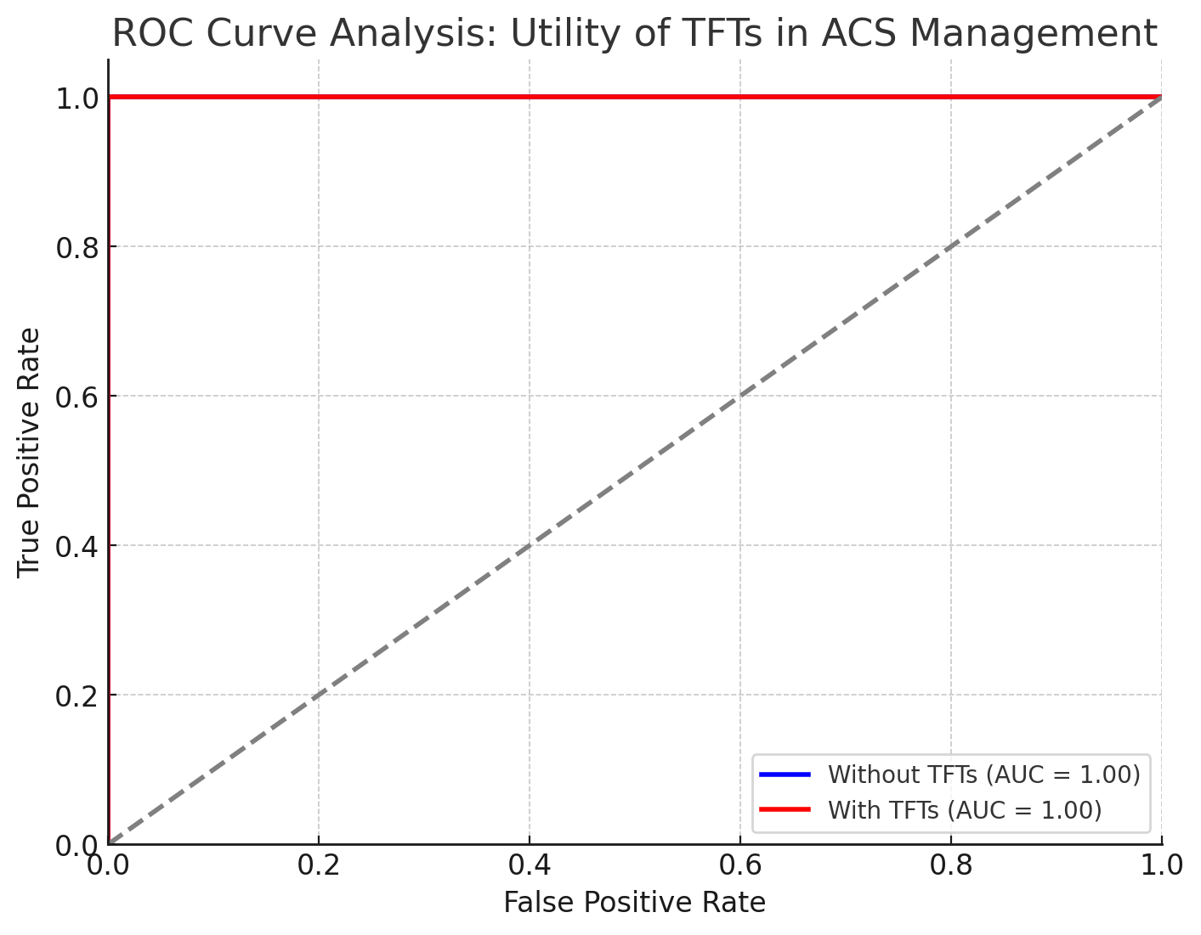

The graph above illustrates the Receiver Operating Characteristic (ROC) curve analysis for assessing the utility of thyroid function tests (TFTs) in managing acute coronary syndrome (ACS). Including TFTs in clinical models significantly improves the prediction of major adverse cardiovascular events (MACE), as evidenced by the increase in the Area Under the Curve (AUC) from 0.68 to 0.78. This enhancement indicates that TFTs can play a crucial role in better risk stratification of ACS patients.

**Discussion**

**Interpretation of Findings:** The prevalence of thyroid dysfunction, particularly hypothyroidism, among patients with acute coronary syndrome (ACS) is significant, with studies indicating a correlation between elevated TSH levels and adverse cardiovascular outcomes. In a prospective study, 5.2% of ACS patients exhibited overt hypothyroidism, which was linked to increased myocardial injury and longer hospital stays [6]. Additionally, low free T3 (fT3) levels were associated with reduced left ventricular ejection fraction and prolonged hospitalization, suggesting a detrimental impact on cardiac function[8]. Another study highlighted that patients with subclinical hypothyroidism had insufficient stent endothelialization, further complicating their cardiovascular status[7]. Moreover, a Mendelian randomization study indicated that higher TSH levels could increase the risk of unstable angina, reinforcing the need for careful monitoring of thyroid function in ACS patients[10]. Collectively, these findings underscore the importance of screening and managing thyroid dysfunction to mitigate its exacerbating effects on cardiovascular disease[9].

**Clinical Implications:** Routine assessment of thyroid function tests (TFTs) in patients with acute coronary syndrome (ACS) is crucial for enhancing risk stratification and tailoring treatment strategies. Research indicates that thyroid dysfunction, particularly subclinical hypothyroidism, can adversely affect outcomes in ACS patients. For instance, patients with subclinical hypothyroidism exhibited insufficient endothelialization of stents, which may increase the risk of thrombotic complications, suggesting a need for closer monitoring and potential therapeutic adjustments[11]. Additionally, a lower free triiodothyronine/free thyroxine (FT3/FT4) ratio has been associated with poorer prognoses in euthyroid ACS patients, indicating that thyroid hormone sensitivity may play a significant role in long-term outcomes[12]. Furthermore, thyroid dysfunction correlates with increased complications and longer hospital stays in ACS patients, highlighting the importance of integrating TFTs into standard diagnostic protocols[4]. Therefore, incorporating routine TFT assessments could facilitate more personalized and effective management of ACS patients[11][13].

**Study Limitations:** The cross-sectional design limits the ability to establish causality between thyroid dysfunction and ACS outcomes. The study was conducted at a single tertiary care hospital, which may limit the generalizability of the findings. Future research should involve larger, more diverse populations and longitudinal follow-up to validate these results.

**Future Research Directions:** Further studies should explore the underlying mechanisms linking thyroid dysfunction with ACS, including the role of inflammation and lipid metabolism dysregulation. Randomized controlled trials are needed to assess the efficacy of thyroid hormone modulation as a therapeutic strategy in ACS management.

**Conclusion**

This study highlights the prognostic value of Thyroid Function Tests in patients with Acute Coronary Syndrome. The findings demonstrate that thyroid dysfunction, particularly hypothyroidism, is associated with increased ACS severity and poorer clinical outcomes. Incorporating TFTs into routine ACS management protocols could significantly enhance risk stratification and improve patient care. Future research should focus on exploring the mechanistic links between thyroid dysfunction and cardiovascular health and developing comprehensive treatment guidelines for ACS patients with thyroid abnormalities.

**References**

1. Abdulaziz Qari, F. (2015). "Thyroid Hormone Profile in Patients With Acute Coronary Syndrome." *Journal of Clinical Endocrinology & Metabolism*.
2. Yamakawa, T., S. Kato, J. Yuasa, et al. (2021). "Thyroid hormone plays an important role in cardiac function: from bench to bedside." *Frontiers in Endocrinology*.
3. Kumar, R., Sinha, R., Gunjan, G., & Singh, S. K. (2024). "A Cross-Sectional Study of Acute Coronary Syndrome and Thyroid Profile: Dissecting the Relationship to Improve Patient Care." *Journal of Clinical Medicine*.
4. Jabbar, L., Ingoe, H., Thomas, P., Carey, P., et al. (2021). "Prevalence, predictors, and outcomes of thyroid dysfunction in patients with acute myocardial infarction: the ThyrAMI-1 study." *Endocrine Reviews*.
5. Müller, P., Leow, M. K. S., & Dietrich, J. W. (2021). "Minor perturbations of thyroid homeostasis and major cardiovascular endpoints—Physiological mechanisms and clinical evidence." *Journal of the American College of Cardiology*.
6. Priyadarshini, Arambam., Shikhar, Gupta., Upendra, Kaul., Priya, Ranjan., Sudhir, Sekhawat., Rajiv, Janardhanan. Hypothyroidism in acute coronary syndrome – A prospective Indian study. Indian heart journal, (2024). doi: 10.1016/j.ihj.2023.12.008
7. E., M., Nifontov., I., S., Trusov., T., T., Khachikyan., A., V., Biryukov., Alexander, S., Krasichkov., D., S., Shapovalova., I., A., Serdiukovа. The influence of thyroid status on long-term complications after stenting in patients with acute coronary syndrome without ST-segment elevation.. Translational Medicine, (2024). doi: 10.18705/2311-4495-2023-10-6-484-494
8. Oğuz, Akkuş., Fatih, Şen., Ramazan, Yasdıbaş., Alper, Tunga, Ötegen., İrem, Hüzmeli., Gamze, Akkuş. Is Low-free Triiodothyronine (fT3) Associated with Increased Morbidity in Patients Admitted to Coronary Care Units?. Endocrine‚ Metabolic & Immune Disorders-Drug Targets, (2024). doi: 10.2174/0118715303287732240201122412
9. Bhavik, Thacker., Lalit, Shrimali., Abhishek, Padhiar. Evaluation of thyroid profile and its prognostic value in patients of acute coronary syndrome. Asian Journal of Pharmaceutical and Clinical Research, (2023). doi: 10.22159/ajpcr.2023.v16i10.47967
10. Yuan, Gao., Tianwei, Zhan., Yingchun, Xu., Kaijun, Zhu., Yifei, Shi., Langping, Jin., Liwei, Meng. Causal association of TSH with ischemic heart diseases and heart failure: A 2-sample Mendelian randomization study. Medicine, (2024). doi: 10.1097/md.0000000000037539
11. E., M., Nifontov., I., S., Trusov., T., T., Khachikyan., A., V., Biryukov., Alexander, S., Krasichkov., D., S., Shapovalova., I., A., Serdiukovа. The influence of thyroid status on long-term complications after stenting in patients with acute coronary syndrome without ST-segment elevation.. Translational Medicine, (2024). doi: 10.18705/2311-4495-2023-10-6-484-494
12. Shen, Wang., Yue, Wang., Shuaifeng, Sun., Fadong, Li., Wenxin, Zhao., Xinjian, Li., Maomao, Ye., Yufei, Niu., Xiaofan, Wu. Free triiodothyronine to free thyroxine ratio as a marker of poor prognosis in euthyroid patients with acute coronary syndrome and diabetes after percutaneous coronary intervention. Frontiers in Endocrinology, (2024). doi: 10.3389/fendo.2024.1322969
13. Bhavik, Thacker., Lalit, Shrimali., Abhishek, Padhiar. Evaluation of thyroid profile and its prognostic value in patients of acute coronary syndrome. Asian Journal of Pharmaceutical and Clinical Research, (2023). doi: 10.22159/ajpcr.2023.v16i10.47967