**In silico; Linoleic acid and palmitic acid exerts antidiabetic effects by inhibiting protein tyrosine phosphatases associated with insulin resistance**

**Maha H.Al-Bahrani1*, Nada A.Kadhim2, Raghad S. Mouhamad3, Khlood Abedalelah Al-Khafaji3**

1 Molecular and Medical Biotechnology Department, College of Biotechnology, Al-Nahrain University Baghdad, Iraq.

2 Chemistry Department, College of Science, University of Baghdad, Baghdad, Iraq.

3 Ministry of Science and Technology, Baghdad, Iraq.

\***Corresponding author:** E-mail: [Dr.mahahameed@gmail.com](mailto:Dr.mahahameed@gmail.com)

**Abstract**

**Objectives:** The search for potential bioactive compounds for the discovery and development of targeted novel antidiabetic drugs is becoming more and more popular among scientists. So, the aim of this research is to find the inhibition activity of palmitic acid and linoleic acid extracted from Ballota saxatilis against protein tyrosine phosphatase (PTP: B1, N9 and 11) through simulation using molecular docking.

**Methods:** Gas chromatography technique (GC) (Chrompack-Packard 438A) and a separation column type 30-SE with an inner diameter of 0.25 mm and a length of 30 m, was used to describe the biologically active chemicals found in Ballota saxatilis extracts.

**Results:** Simulation technique gave the binding affinity, hydrogen bonding and the distances between ligand and its corresponding enzyme molecule. Molecular docking revealed that palmitic acid had strong binding affinities for PTP1B (-7.8) and PTP9 (-7.9) but had weaker affinities for PTP11 (up to (-7.4). α- Linoleic Acid (ALA) produced closely results of binding activity against PTP1B (-6.2) and PTP9 (-6.1) and lower binding activity reacted with PTP11. However, the ligand α- Linoleic acid could form hydrogen bonding beside other interactions with PTP1B, PTPN9 and PTPN11. The other ligand palmitic acid formed mainly hydrophobic interactions with the three enzymes. Only one hydrogen bond existed between ligand palmitic acid and the amino acid Lys260 located at PTPN11

**Conclusions:** The extract of herb B. saxitalis could be applied by the researchers, and pharmaceutical companies around the world for inhibition of PTP1B, PTPN9 and PTPN11. These compounds may control diabetes with fewer side effects than conventional antidiabetic medications.

**Keywords:** Inhibiting protein tyrosine phosphatases, Diabetes, Phytochemical, Phytomedicine, Drug development.

**Introduction**

The superfamily of PTPs' prototype, protein tyrosine phosphatase 1B (PTP 1B), has been connected to several signaling pathways [1]. PTPs may provide a new class of therapeutic targets since certain particular PTPs, including PTPN1, PTPN2, PTPN9, PTPN11, PTPRF, PTPRS, and DUSP9, are linked to the inhibition of insulin signaling and cause insulin resistance that is important for the onset of type-2 diabetes [2]. The conserved intracellular energy sensor known as AMP-activated protein kinase (AMPK) controls the metabolism of glucose and lipids. When activated, AMPK promotes glucose uptake and lipid oxidation in skeletal muscle and adipose tissues [3].

The widely used hypoglycemic medications metformin and thiazolidinedione increase AMPK activity, showing that AMPK is a marker for an anti-diabetic effect [4]. PTP, non-receptor type 1 (PTPN1, also known as PTP1B), which is connected to the negative regulation of insulin action, raises the possibility that inhibiting PTPN1 might be a therapeutic approach for the management of type 2 diabetes [5]. PTP1B, a non-receptor protein phosphatase that phosphorylates tyrosine, is regarded as a key negative regulator of both insulin- and leptin-simulated signal transduction. Previous research has shown that the absence of PTP1B can increase insulin sensitivity, improve glycemic management, and protect against the obesity-inducing effects of high-fat diets [6].

Additionally, treating diabetic mice with PTP1B antisense oligonucleotides might lower PTP1B expression levels, regulate blood sugar levels, and ultimately improve insulin sensitivity [7]. PTP1B inhibitors may improve insulin and leptin sensitivity and function as efficient treatments for type II diabetes, insulin resistance, and obesity, according to some research [8]. Gene-targeting experiments in mice have identified PTP1B as a crucial physiological regulator of metabolism by attenuating insulin, leptin, and growth hormone signaling, making it a promising therapeutic target for type II diabetes and obesity [9].

It appears that PTP1B function is not necessary for embryonic development. The two main metabolic disorders in industrialized societies—diabetes and obesity—are resistant in PTP1B-deficient animals, nevertheless [10]. It should come as no surprise that the pharmaceutical industry holds PTP1B in high esteem as a target for the therapy of these illnesses [11].

Both PTP, non-receptor type 9 (PTPN9, also known as PTP-MEG2) and PTP, non-receptor type 11 (PTPN11, also known as SHP-2), were identified as promising anti-diabetic targets, and chebulinic acid was shown to be their targeted inhibitor [12]. The use of inhibitors against PTPN1, PTPN9, or PTPN11 is regarded as an effective method for treating type 2 diabetes since it has been demonstrated that they enhance insulin sensitivity and the PTP associated with insulin resistance [13].

Fatty acids (FFAs) that play a significant role in insulin control and beta-cell activity include palmitic acid (PA), which has been demonstrated to stimulate mTOR signaling in rat hepatocytes [14]. Increased saturated FFA concentrations influence insulin biosynthesis secretion, -cell content, and also cause cell stress. This, in turn, causes lipotoxicity, which may cause -cell function to be lost, and plays a direct role in the pathophysiology of T2D [15]. FFAs affect the control of insulin via binding to their primary receptor, FFA receptor 1 (FFAR1), also known as GPR40 [16]. G-protein coupled receptor FFAR1, which primarily expresses in pancreatic beta-cells, has seven transmembrane domains [17]. Different medium- and long-chain (C12-C22) FFAs activate -cells, causing a rise in intracellular calcium levels and the stimulation of insulin secretion, which increases the insulinotropic capability of glucose and amplifies glucose-stimulated insulin secretion (GSIS). However, it is still unknown how exactly FFAR1 works [18.19].

Insulin secretion, insulin resistance, and glucose absorption have all been identified as the mechanisms of action underpinning the reported anti-diabetic benefits. Although there are several distinct groups of polyphenols for the treatment of diabetes that have not been completely researched, the quest for novel therapeutic targets continues to be difficult. Overall, this research sought to determine the total fatty acid content of Ballota saxatilis extracts and to assert potential antidiabetic properties using an in silico approach by simulating the interactions of linolenic and palmitic acids with target cell signaling proteins involved in the onset of diabetes.

**Material and methods**

*Ballota saxatilis* leave was purchased at the neighborhood market in Baghdad Province, Iraq, for the extraction of biologically active chemicals. The plant was thoroughly cleansed of any other herbs, thoroughly washed, and then gently dried on paper towels. In the meantime, dried plant blooms were harvested using paper bags and stored for roughly 30 days in a dark environment with a temperature of 25oC [17].

Finely powdered dried leaves were sieved through a 0.4 mm mesh panel after being pounded into powder. According to the aforementioned procedure, alfalfa aqueous extracts were made using water, ethanol, and other ingredients. A sample of 500 g of dried alfalfa flowers powder was extracted with 100 ml of 99% ethanol or water and left on a water path that had been heated to 60oC for 20 minutes. The extract was recovered using a vacuum filtering assembly, and the material from the extract was dried using a rotary evaporator. The finished powder was weighed and kept at 4°C in a tight container until use.

**Mass spectrometry using gas chromatography (GC-MS)**

Using the gas chromatography technique (GC) (Chrompack-Packard 438A) and a separation column type 30-SE with an inner diameter of 0.25 mm and a length of 30 m, according to the method described in, the biologically active chemicals were found in *Ballota saxatilis* extracts [17].

**Research on molecular docking**

To determine which ligand molecule and the researched PTPs fit together the best, the key hypothesis and locking were employed. The crystal structure of the protein was reconstructed by RCSB as a PDB file and imported into molegro virtual Docker. Palmitic acid and **α-** Linoleic acid were used as ligand and described from *B.sexatilis*. The ligand receptor's binding mechanism did not include water molecules. Water molecules were deleted to prevent their additional H- bonding in order to optimize computation and avoid potential distortion following a docking procedure [18].

**Preparation of biologically active chemicals**

In the current investigation, various bioactive substances were employed. These substances were examined in aqueous extracts of dried leave from the plant *Ballota saxatilis*. Then, the ligands were produced for docking along with the MVD molecules. The 3D ligand structures were created with assistance from UCSF, while the 2D structures were taken from the ZINC15 chemical database. In order to build ligands, the UCSF Chimera Structure Build module was employed (minimises energy consumption, adds hydrogen atoms and adds charges when needed). The 3D structure of each drug was created, saved in pdb format, and then optimized for docking utilizing UCSF Chimera tools.

**Results:**

The development of rational structure-based medicines frequently makes use of contemporary techniques like molecular docking. It is used to predict the intensity of the forces at play, evaluate the complex interactions between small ligands and massive macromolecules, and pinpoint the optimal geometric arrangements.

Molecular docking revealed that palmitic acid had strong binding affinities for PTP1B (-7.8) and PTP9 (-7.9) but had weaker affinities for PTP11 (up to (-7.4. **α-** Linoleic Acid (ALA) produced closely results of binding activity against PTP1B (-6.2) and PTP9 (-6.1) and lower binding activity reacted with PTP11 (-5.7) (Table 1).

**Table 1: The interaction between the protein tyrosine phosphatase 1Band ligand α-** **Linoleic acid and palmitic acid.**

|  |  |  |  |  |
| --- | --- | --- | --- | --- |
| **Complex** | **Binding affinity** | **Interacting residues** | **H-Bond interaction** | **Distance** |
| PTP1B-ChEBI_15756(Palmitic acid) | -7.8 | -- | -- | -- |
| PTP1B_ChEBI_27432(**α-** Linoleic acid) | -6.2 | Gly220(A)  Phe182(A) | O1-N  O2-N | 3.22  3.17 |

From stimulation data we recognized that palmitic acid and α**-** Linoleic acid could interact through different type of linkages with the protein molecule of enzyme PTP1B-ChEBI as presented in Figure (1 A, B).

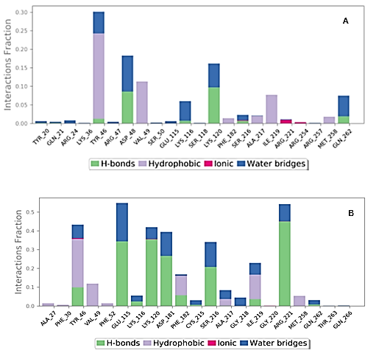

**Figure 1: The contact between protein PTP1B and the ligand (A) palmitic acid (B) α-** **Linoleic acid.**

The molecular dynamic of protein with ligands showed that ligand palmitic acid with higher affinity inserted itself through hydrophobic interaction but without intra-hydrogen bonding with protein molecule while, ligand **α-** Linoleic acid interacted via hydrogen bonds with PTP1B protein at glycine 220 with distance 3.22 A and the amino acid phenyl alanine 182 with distance 3.17A as shown in Figure (2 A, B).

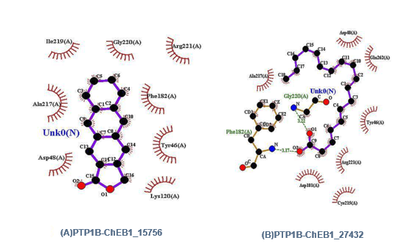

**(A)PTP1B-ChEB1_15756**

**Figure 2: Schematic figure represent molecular dynamic of interaction between the enzyme PTP1B and ligands palmitic acid (A) and α- Linoleic acid (B).**

**Table 2: The interaction between the protein tyrosine phosphatase non- receptor 9 and ligand α- Linoleic acid and palmitic acid.**

|  |  |  |  |  |
| --- | --- | --- | --- | --- |
| **Complex** | **Binding affinity** | **Interacting residues** | **H-Bond interaction** | **Distance** |
| PTPN9_ChEBI_palmitic acid | -7.9 | --- | ---- | --- |
| PTPN9_ChEBI- **α-** Linoleicacid | -6.1 | Glu313(B)  Arg551(B) | O2-O  O1-NE | 3.17  3.07 |

Our results indicated that interaction between protein molecule and ligand palmitic acid (A) and the second ligand **α-** Linoleic acid (B); both ligands interacted with PTPN9 via different bonds (Table 2 and Figure 3 A, B).

Despite the interaction, the molecular dynamic of protein PTPN9 with ligands indicated that ligand palmitic acid inserted by hydrophobic interaction without intra-hydrogen bonding with protein molecule while, ligand **α-** Linoleic acid interacted via hydrogen bonds at position of amino acid Glu313 with distance 3.17A and the amino acid Arg551 with distance 3.07A as shown in Figure (4 A, B).

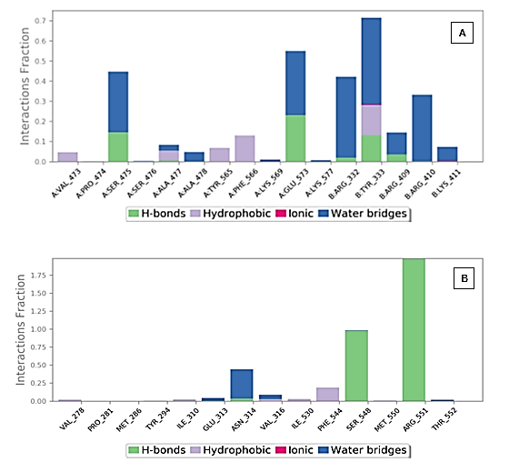

**Figure (3): The contact between protein PTP9B and the ligand (A) palmitic acid (B) α-** **Linoleic acid.**

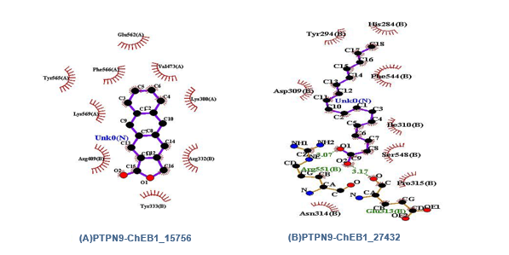

**Figure 4: Schematic figure represent Molecular dynamic of interaction between PTP9 enzyme and ligand palmitic acid (A) and α-** **Linoleic acid (B).**

The third target presented here was PTP11 that interacted with both ligands through formation hydrogen bonds at position Lys260 (A) and Asp477 (A) table (3) and via different bonds (Table 3 and Figure 5 A, B).

**Table 3: The interaction between the protein tyrosine phosphatase non-receptor 11 and ligand Linoleic acid and palmitic acid.**

|  |  |  |  |  |
| --- | --- | --- | --- | --- |
| **Complex** | **Binding affinity** | **Interacting residues** | **H-Bond interaction** | **Distance** |
| PTPN11_ChEBI_15756(palmitic) | -7.4 | Lys260(A) | O1-NZ | 2.99 |
| PTPN11_ChEBI_27432(**α-** Linoleic) | -5.7 | Asp477(A) | O2-OD2 | 2.96 |

Molecular dynamic focused on the PTP11 protein ensured that hydrogen bond would occur between the amino acid Lysine 260(A) and ligand palmitic acid at distance 2.99A while hydrogen bond detected at position Asparagine 477(A) with distance 2.96A (Figure 6 A, B); such finding was very interested for targeting the protein molecule of PTP11 as a third option for diabetes treatment.

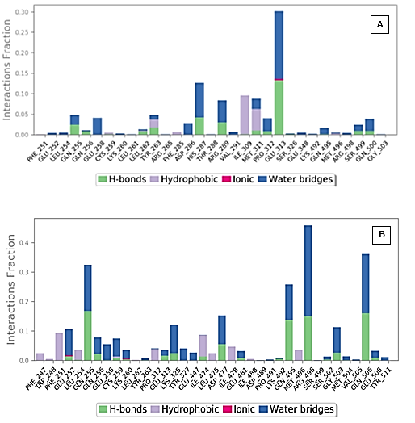

**Figure 5: The contact between protein PTP11 and the ligand (A) palmitic acid (B) α-** **Linoleic acid.**

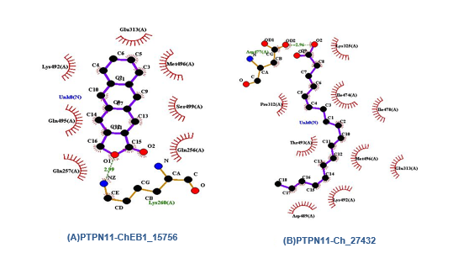

**Figure 6: Schematic figure represent Molecular dynamic of interaction between PTP11 enzyme and ligand palmitic acid (A) and α-** **Linoleic acid (B).**

**Discussion**

In addition to fat deposition and lipid buildup in the belly and visceral compartments, which cause age-enhanced insulin resistance or hyperinsulinemia, insulin resistance has been identified as a distinguishing characteristic of the natural aging process (20). Activation of the polyol pathway, increased production of intracellular AGOs like glycated red blood cells, activation of protein kinase C isoforms, and excessive activity of the hexose amine pathway are all effects of hyperglycemia. When these routes are combined, they enhance the generation of free radicals such superoxide, hydrogen peroxide, and hydroxyl radicals, which have a negative impact on cells by increasing oxidative stress and harming microvascular endothelial cells. All of them contributed to the development of DM sequelae as diabetes retinopathy, nephropathy, and neuropathy. Additionally, macrovascular issues such as: stroke complications in type 2 DM, peripheral arterial disease, and coronary artery disease (20, 21).

Dietary habits were known to help diabetics with type 2 regulate their glycemic parameters; the American and Canadian Diabetes Associations advised eating more foods with unsaturated fats rather than saturated and trans fats. Numerous studies had recommended numerous species of the genus *Ballota* as a secure and affordable dietary supplement for a variety of illnesses (22). Founding by Ghaedi et al., (23) concluded *Ballota glandulosissima* might use as a supplement by diabetic 2 patients due to its inhibitory action against the enzymeα-glucosidase. While According to earlier research by Abdullah et al. (24) on diabetic rats, the aqueous extract of *Ballota saxatilis* may have potential anti-hyperglycemic actions. This may be more potent than the prior anti-diabetic properties of other *Ballot*a genus members like *B. nigra* and *B. undulate* (25). *Ballota saxatilis* was examined for its chemical composition using GC-Mass, and it was discovered that the extract contained palimitic acid and - **α-** Linoleicacid (ALA), both of which were designed for in silico studies of their effects as antidiabetics against protein tyrosine phosphatases (PTPs), which are an emerging paradigm for the development of anti-diabetic drugs.

Jiang et al. (26) considered that PTP1B is a promising drug target for the treatment of diabetes type 2 as well as obesity through its action as a negative regulator of insulin receptor signaling and they reviewing different natural product could had a potent inhibitory activity against PTP1B.

Many researches (27, 28, 29, 30) deal with the importance of the expression of the gene responsible for PTP1B protein expression and its relation with the insulin resistance lead to type 2 Diabetes. Other researches, describe the mimetic of insulin through the function of non- selective inhibitors against PTP1B enzyme. However, other dephosphorates enzymes could activate insulin receptor. For this hypothesis, we concluded the PTP 9 as a second target for our extracts.

By reducing insulin resistance, the enzyme PTP11 has previously been identified as a target for the treatment of diabetes. This protein is expressed in a variety of tissues and is essential for controlling many cell functions. PTP 11 regulates transcription, mitogenic activation, and cell migration in addition to metabolic regulation. Several phytochemicals have the ability to control either one or both of the molecules; Omega-3 also increases fatty acid oxidation and decreases de novo lipogenesis, which results in less hepatic fat buildup and maintains hepatic insulin sensitivity. The release of glucagon-like peptide-1, which is regulated by GPR120, is another explanation put out to explain how omega-3 fatty acids have anti-diabetic effects (31, 32). Numerous studies shown that long-chain monounsaturated fatty acids and diets rich in -linoleic acid encourage and enhance the release of GLP-1 by murine rat and human L cells, which raises blood levels of insulin (33).

**Conclusion**

The first line of treatment for type 2 DM is oral anti-diabetic medication. In addition to insulin resistance, type 2 diabetes is also characterized by an increase in oxidative stress, which leads to the depletion of the cellular antioxidant defense system. Dietary habits were known to help diabetics with type 2 regulate their glycemic parameters; the American and Canadian Diabetes Associations advised eating more foods with unsaturated fats rather than saturated and trans fats. Numerous in vitro and animal investigations have shown that ALA regulates insulin sensitivity by influencing glucose homeostasis through putative roles in gene regulation, fat metabolism, and adipocyte development. Various species of the genus *Ballota* have been recommended by numerous studies as a secure and affordable dietary supplement for a variety of ailments.

As a result, the present study recommends *B. saxatilis* as a brand-new oral hypoglycemic agent. The plant's growing in the Iraqi environment and the use of its extracts in dietary regimens both require more research. Form a substantial class of phytocompounds that are widely distributed and have demonstrated therapeutic activity against a number of clinical disorders, including neurological illnesses. PTPs, or protein tyrosine phosphatases, are a promising target for the creation of anti-diabetic medications.

**References**

1. Villamar-Cruz O, Loza-Mejía MA, Arias-Romero LE, Camacho-Arroyo I. Recent advances in PTP1B signaling in metabolism and cancer. Biosci Rep. 2021 Nov 26;41(11):BSR20211994.
2. Singh, S., Singh Grewal, A., Grover, R., Sharma, N., Chopra, B., Kumar Dhingra, A., Arora, S., Redhu, S., & Lather, V. Recent updates on development of protein-tyrosine phosphatase 1B inhibitors for treatment of diabetes, obesity and related disorders. Bioorganic chemistry 2022; 121: 105626.
3. Long YC, Zierath JR. AMP-activated protein kinase signaling in metabolic regulation. J Clin Invest. 2006 Jul;116 (7):1776-83.
4. Coughlan KA, Valentine RJ, Ruderman NB, Saha AK. AMPK activation: a therapeutic target for type 2 diabetes? Diabetes Metab Syndr Obes 2014 Jun 24; 7:241-53.
5. Liu R, Mathieu C, Berthelet J, Zhang W, Dupret J-M, Rodrigues Lima F. Human Protein Tyrosine Phosphatase 1B (PTP1B): From Structure to Clinical Inhibitor Perspectives. International Journal of Molecular Sciences 2022; 23(13):7027.
6. Ranjithmenon Muraleedharan, Biplab Dasgupta, AMPK in the brain: its roles in glucose and neural metabolism, The FEBS Journal, 10.1111/febs 2021; 16151, **289**, 8: 2247-2262.
7. Zinker, B. A., Rondinone, C. M., Trevillyan, J. M., Gum, R. J., Clampit, J. E., Waring, J. F., Xie, N., Wilcox, D., Jacobson, P., Frost, L., Kroeger, P. E., Reilly, R. M., Koterski, S., Opgenorth, T. J., Ulrich, R. G., Crosby, S., Butler, M., Murray, S. F., McKay, R. A., Bhanot, S., Jirousek, M. R. PTP1B antisense oligonucleotide lowers PTP1B protein, normalizes blood glucose, and improves insulin sensitivity in diabetic mice. Proceedings of the National Academy of Sciences of the United States of America 2002*;* 99(17): 11357–11362.
8. Aberdein N, Dambrino RJ, do Carmo JM, Wang Z, Mitchell LE, Drummond HA, Hall JE. Role of PTP1B in POMC neurons during chronic high-fat diet: sex differences in regulation of liver lipids and glucose tolerance. Am J Physiol Regul Integr Comp Physiol 2018*;* Mar 1; 314(3):R478-R488.
9. Abdelsalam SS, Korashy HM, Zeidan A, Agouni A. The Role of Protein Tyrosine Phosphatase (PTP)-1B in Cardiovascular Disease and Its Interplay with Insulin Resistance. Biomolecules 2019 Jul 17;9(7):286.
10. Dubé N, Cheng A, Tremblay ML. The role of protein tyrosine phosphatase 1B in Ras signaling. Proc Natl Acad Sci U S A 2004 Feb 17; 101(7):1834-9.
11. Kumar, A., Rana, D., Rana, R., & Bhatia, R. Protein Tyrosine Phosphatase (PTP1B): A promising Drug Target Against Life-threatening Ailments. Current molecular pharmacology 2020 ; 13(1), 17–30.
12. Desjarlais M, Ruknudin P, Wirth M, Lahaie I, Dabouz R, Rivera JC, Habelrih T, Omri S, Hardy P, Rivard A, Chemtob S. Tyrosine-Protein Phosphatase Non-receptor Type 9 (PTPN9) Negatively Regulates the Paracrine Vasoprotective Activity of Bone-Marrow Derived Pro-angiogenic Cells: Impact on Vascular Degeneration in Oxygen-Induced Retinopathy. Front Cell Dev Biol. 2021 May 28;9: 679906.
13. Yoon SY, Yu JS, Hwang JY, So HM, Seo SO, Kim JK, Jang TS, Chung SJ, Kim KH. Phloridzin Acts as an Inhibitor of Protein-Tyrosine Phosphatase MEG2 Relevant to Insulin Resistance. Molecules. 2021 Mar 14; 26(6):1612.
14. Oh YS, Bae GD, Baek DJ, Park EY, Jun HS. Fatty Acid-Induced Lipotoxicity in Pancreatic Beta-Cells During Development of Type 2 Diabetes. Front Endocrinol (Lausanne). 2018 Jul 16; 9:384.
15. Drożdż K, Nabrdalik K, Hajzler W, Kwiendacz H, Gumprecht J, Lip GYH. Metabolic-Associated Fatty Liver Disease (MAFLD), Diabetes, and Cardiovascular Disease: Associations with Fructose Metabolism and Gut Microbiota. Nutrients. 2021 Dec 27; 14(1):103.
16. Tsuda N, Kawaji A, Sato T, Takagi M, Higashi C, Kato Y, Ogawa K, Naba H, Ohkouchi M, Nakamura M, Hosaka Y, Sakaki J. A novel free fatty acid receptor 1 (GPR40/FFAR1) agonist, MR1704, enhances glucose-dependent insulin secretion and improves glucose homeostasis in rats. Pharmacol Res Perspect. 2017 Aug; 5(4):e00340.
17. Fridlyand LE, Philipson LH. Pancreatic Beta Cell G-Protein Coupled Receptors and Second Messenger Interactions: A Systems Biology Computational Analysis. PLoS One. 2016 May 3;11 (5):e0152869.
18. Kalis M, Levéen P, Lyssenko V, Almgren P, Groop L, Cilio CM. Variants in the FFAR1 gene are associated with beta cell function. PLoS One. 2007 Nov 7;2(11):e1090.
19. Park MH, Kim DH, Lee EK, Kim ND, Im DS, Lee J, Yu BP, Chung HY. Age-related inflammation and insulin resistance: a review of their intricate interdependency. Arch Pharm Res. 2014 Dec;37(12):1507-14.
20. Roberts CK, Hevener AL, Barnard RJ. Metabolic syndrome and insulin resistance: underlying causes and modification by exercise training. Compr Physiol. 2013 Jan;3(1):1-58.
21. Ley SH, Hamdy O, Mohan V, Hu FB. Prevention and management of type 2 diabetes: dietary components and nutritional strategies. Lancet. 2014 Jun 7;383(9933):1999-2007.
22. Salas-Salvadó, J., Martinez-González, M. Á., Bulló, M., & Ros, E. The role of diet in the prevention of type 2 diabetes. Nutrition, metabolism, and cardiovascular diseases: NMCD (2011); 21 Suppl 2, B32–B48.
23. Ghaedi N, Pouraboli I, Askari N. Antidiabetic Properties of Hydroalcoholic Leaf and Stem Extract of Levisticum officinale: An implication for α-amylase Inhibitory Activity of Extract Ingredients through Molecular Docking. Iran J Pharm Res. 2020 Winter;19(1):231-250.
24. Abdullah, M., Al-Khafaji, K., Mouhamad, R., & Hussein, R. In-vivo study of the anti-diabetic effect of Ballota saxatilis. DYSONA - Life Science 2020; 1(2), 70-75.
25. Azadbakht L, Rouhani MH, Surkan PJ. Omega-3 fatty acids, insulin resistance and type 2 diabetes. J Res Med Sci. 2011 Oct;16 (10):1259-60.
26. Jiang, Cs., Liang, Lf. & Guo, Yw. Natural products possessing protein tyrosine phosphatase 1B (PTP1B) inhibitory activity found in the last decades. Acta Pharmacol Sin. 2012; 33, 1217–1245.
27. Dass AS, Narayana S, Venkatarathnamma PN. Effect of Vitamin E and omega 3 fatty acids in type 2 diabetes mellitus patients. J Adv Pharm Technol Res. 2018 Jan-Mar;9(1):32-36.
28. Jovanovski E, Li D, Thanh Ho HV, Djedovic V, Ruiz Marques AC, Shishtar E, Mejia SB, Sievenpiper JL, de Souza RJ, Duvnjak L, Vuksan V. The effect of alpha-linolenic acid on glycemic control in individuals with type 2 diabetes: A systematic review and meta-analysis of randomized controlled clinical trials. Medicine (Baltimore). 2017 May; 96(21):e6531.
29. Sharma, C., Kim, Y., Ahn, D. et al. Protein tyrosine phosphatases (PTPs) in diabetes: causes and therapeutic opportunities. Arch. Pharm. Res. 2021; 44, 310–321.
30. Ruddraraju KV, Zhang ZY. Covalent inhibition of protein tyrosine phosphatases. Mol Biosyst. 2017 Jun 27;13 (7):1257-1279.
31. Yue X, Han T, Hao W, Wang M, Fu Y. SHP2 knockdown ameliorates liver insulin resistance by activating IRS-2 phosphorylation through the AKT and ERK1/2 signaling pathways. FEBS Open Bio. 2020 Dec;10(12):2578-2587.
32. Saini V. Molecular mechanisms of insulin resistance in type 2 diabetes mellitus. World J Diabetes. 2010 Jul 15;1(3):68-75.
33. Paschoal VA, Walenta E, Talukdar S, Pessentheiner AR, Osborn O, Hah N, et al. Positive Reinforcing Mechanisms Between GPR120 and Pparγ Modulate Insulin Sensitivity. Cell Metab. 2020; 31(6):1173–88.e5.