**Nabothian cyst association with infertility in female by trans-abdominal and trans-vaginal ultrasound**

Dr. Zena M. AL - Hindawi.

Department of anatomy and embryology, college of medicine, Kerbala University, Iraq.

[Zalhindawi@yahoo.com](mailto:Zalhindawi@yahoo.com)

[Zina.Mahdi@uokerbala.edu.iq](mailto:Zina.Mahdi@uokerbala.edu.iq)

**Abstract:**

Female infertility contributed to many causes that involve genetic and acquired abnormalities of uterus. We depend on ultrasound in a large number of patients because it is an excellent, fast, safe and inexpensive method for assessing size, shape, and determining abnormalities of uterus and both ovaries. Nabothian cyst is one of the causes of infertility which can assess by ultrasound.

**Objective:**

To visualize nabothian cyst by ultrasound and its association with infertility in women.

**Methods:**

This is a study, involving 144 females age 20 - 45 years from ultrasound clinic from Dec 2020 to April 2022, the examination was done by Samsung HS50 ultrasound device (KOREA), using endo-vaginal and transabdominal approach with EVN 4-9 MHZ and CA1-7AD probes respectively. Women with genital anomaly and polycystic ovary syndrome not included in this study.

**Results:**

144 patients involve in this study with mean age of patients was 31.36 ± SD 6.33 (20 -45 years) , 97 (67.4% ) primary infertility and 47 (32.6%) secondary infertility. Out of 144 patients who have nabothian cyst was present; 1 in 43 (29.9%), 2 in 31(21.5%), 3 in 51(35.4%) and 4 in 19 (13.4%).

**Conclusions:**

The study established an important association between the size and number of Nabothian cyst with infertility.

**Key words:**

Ultrasound, Nabothian cyst, Infertility.

**Introduction:**

Infertility is a common problem that affects couple's, it define as a failure of couple's to conceive over a one year without use of contraception (1). Infertility in female either primary or secondary. It is caused by a large number of causes that are either genetic or acquired problems, the causes: uterine or cervical abnormalities, fallopian tube damage or blockage and Ovulation disorders. Cervical factor in infertility may result from blockage or narrowing of cervical opening, so sperm cannot reach fallopian tubes. Nabothian cysts one of causes of cervical opening narrowing or blockage , they are retention cysts (2) . Nabothian cysts, also called inclusion cysts are the result of retention of secretion of nabothian gland. Is a frequent finding in asymptomatic woman. They are usually multiple, size differ from few millimeters to 3 cm. Small cyst are asymptomatic while large cyst may cause heaviness in vagina ,chronic pelvic pain and irregular vaginal bleeding (3,5,6), also may cause watery vaginal secretion(4) . Very large nabothian cyst may protrude out of the vagina or may cause pelvic organs prolapse. Nabothian cyst result from occlusion of the cervical glands. Rarely have correlation with chronic cervicitis(5) . In general they are multiple, their color white or yellow, shiny or opaque in appearance with size ranging from few millimeters to four centimeters in diameter (6).

Ultrasound examination of the female pelvis is commonly perform as the first step imaging modality for diagnosis of many uterine and adnexal pathologies .By ultrasound the cervix appears as cylindrical in shape in the sagittal view, and rounded in shape in the axial view. Both transabdominal and transvaginal ultrasound are used in female pelvis examination. Abdominal approach for general description of pelvic anatomy. Vaginal approach gives better anatomical details, characterization of tissue, and demonstration of vascular flow.  All cervical canal must be examined from the internal os to the external os searching for any solid or cystic lesion. Color Doppler can detect vascularity of lesion and aid in diagnosis of benign from malignant lesion. In the evaluation of cervical lesion, transvaginal approach is better than transabdominal scanning for their detection.

Nabothian cyst is easily detected by ultrasound either by transabdominal or transvaginal probe. Transvaginal approach is most effective way for detection of these cysts. Nabothian cysts appear by ultrasound as well define, regular outline echo free cystic lesions(7),thin wall with acoustic enhancement ,avascular on color Doppler as shown in figure 1 and 2. Tunnel clusters are a subtype of nabothian cysts which appear as complicated multicystic lesion which must be differentiated from cervical malignancy. The early detection and treatment of nabothian cys can decrease female infertility slightly and so we overcome many medical and social problems.

**Methodology:**

This study was conducted at ultrasound clinic, Kerbala, Iraq. Time of study was 17 months, 144 females are included in this study. Verbal approval was taken from all females before performing ultrasound exam. Technique of sampling utilized was convenient sampling. Age of females between 20-45 years. All females with infertility either primary or secondary were included in this study, females that are excluded from the study those who present with polycystic ovarian syndrome and those with anomalies of genital tract. Samsung HS50 ultrasound device (KOREA), using endo-vaginal and transabdominal approach with EVN 4-9 MHZ and CA1-7AD probes respectively. Examination was done for uterus, vagina and both adnexa after taking full history of patients mainly about her infertility state. Female who perform trans-abdominal approach come with full urinary bladder and those who perform trans- vaginal approach with empty bladder. Ultrasound exam to the pelvis was done using ultrasound device to scan uterus and cervix in both plane longitudinal and transverse plane for best visualization. Nabothian cyst was measured. These measurements were done by putting the caliper of the ultrasound device on the borders of the cyst. The collected data from patients was analyzed by SPSS version 24. The qualitative variables such as age, infertility state either primary or secondary, size or number of Nabothian cyts were presented as frequencies and percentages by tables. Mean, minimum, maximum and standard deviation was considered for quantitative variables.

**Result:**

144 patients involve in this study, their statistical result done using graphs and frequency tables. Table 1 showing mean age of patients was 31.36 ± SD 6.33 (ranging between 20 -45 years) as below:

**Tab 1 descriptive statistics of age:**

|  |  |
| --- | --- |
| Age | |
| No. 144 | |
| Mean | 31.36 |
| Std. Deviation | 6.334 |
| Minimum | 20 |
| Maximum | 45 |

Table 2 showing fertility state of female with 97 (67.4%) primary infertility and 47 (32.6%) secondary infertility.

Tab 2 Frequency of primary and secondary infertility:

|  |  |  |  |  |  |
| --- | --- | --- | --- | --- | --- |
|  | | Frequency | Percent | Valid Percent | Cumulative Percent |
|  | primary infertility | 97 | 67.4 | 67.4 | 67.4 |
| secondary infertility | 47 | 32.6 | 32.6 | 100.0 |
| Total | 144 | 100.0 | 100.0 |  |

|  |
| --- |
|  |

Regarding tables from 3 – 6 which show number of cysts and their frequency in primary and secondary infertility, in tab 3 out of 144 patients with one nabothian cyst seen in 30 female (20.8%) with primary infertility and 13 (9%) with secondary infertility, rest (100 female ,70.1%) have another number of cyst. In tab 4 out of 144 females with two cysts seen in 23(16%) with primary infertility and 8 (5.6%) with secondary infertility, (113 female 78.5% have another number of cyst). In tab 5 out of 144 female have three cyst in 36 (25%) with primary infertility and 15(10.4%) with secondary infertility, 93 female (64.6%) have another. Table 6 out of 144 females with four cysts seen in 14 (9.7%) with primary infertility and 5 (3.5%) with secondary infertility, 125 (86.8%) have another number of cysts. Size of cyst ranging between 2-14 mm. Table 7 show mean size of nabothian cyst was 5.31 mm ± SD 2.6 (minimum size was 2mm and maximum size was 14 mm) as shown below.

Tab 3 frequency of patient having one nabothian cyst in primary and secondary infertility:

|  |  |  |  |  |  |
| --- | --- | --- | --- | --- | --- |
| **One Nabothian cyst** | | | | | |
|  | | Frequency | Percent | Valid Percent | Cumulative Percent |
|  | primary infertility | 30 | 20.8 | 20.8 | 20.8 |
| secondary | 13 | 9.0 | 9.0 | 29.9 |
| have another number | 101 | 70.1 | 70.1 | 100.0 |
| Total | 144 | 100.0 | 100.0 |  |

Tab 4 frequency of patient having two nabothian cysts in primary and secondary infertility:

|  |  |  |  |  |  |
| --- | --- | --- | --- | --- | --- |
| **Two** **Nabothian cysts** | | | | | |
|  | | Frequency | Percent | Valid Percent | Cumulative Percent |
|  | primary infertility | 23 | 16.0 | 16.0 | 16.0 |
| secondary infertility | 8 | 5.6 | 5.6 | 21.5 |
| have another number | 113 | 78.5 | 78.5 | 100.0 |
| Total | 144 | 100.0 | 100.0 |  |

Tab 5 frequency of patient having three nabothian cysts in primary and secondary infertility:

|  |  |  |  |  |  |
| --- | --- | --- | --- | --- | --- |
| **Three** **Nabothian cysts** | | | | | |
|  | | Frequency | Percent | Valid Percent | Cumulative Percent |
|  | primary infertility | 36 | 25.0 | 25.0 | 25.0 |
| secondary infertility | 15 | 10.4 | 10.4 | 35.4 |
| have another number | 93 | 64.6 | 64.6 | 100.0 |
| Total | 144 | 100.0 | 100.0 |  |

Tab 6 frequency of patient having four nabothian cysts in primary and secondary infertility:

|  |  |  |  |  |  |
| --- | --- | --- | --- | --- | --- |
| **Four** **Nabothian cysts** | | | | | |
|  | | Frequency | Percent | Valid Percent | Cumulative Percent |
|  | primary infertility | 14 | 9.7 | 9.7 | 9.7 |
| secondary infertility | 5 | 3.5 | 3.5 | 13.2 |
| have another number | 125 | 86.8 | 86.8 | 100.0 |
| Total | 144 | 100.0 | 100.0 |  |

Table 7 descriptive statistics of size of nabothian cyst:

|  |  |
| --- | --- |
| size | |
| No.144 | |
| Mean | 5.31 |
| Std. Deviation | 2.600 |
| Minimum | 2 |
| Maximum | 14 |

**Discussion:**

Infertility has many effects on couple life from social and medical aspect. There are many causes of infertility , 40% attributed to the wife , 40% attributed to the husband, 5% - 10% to both partners, and 5% to 10% without known cause(8). In female partner the causes of infertility either ovarian dysfunction, tubal causes, uterine and cervical causes. Nabothian cyst one of cervical causes which may cause cervical obstruction. Nabothian cyst are mucous retention cyst seen in reproductive age women (9), they result from proliferation of the squamous epithelium of the ectocervix above the columnar epithelium of the endocervix. The gland of endocervix continuously secrete mucoid material which become collected under the squamous proliferation and retention cysts form (10, 11), usually symptom less, common incidental finding. They ranging from few millimeter up to 4 cm, reaching this large size can cause symptom like abdominal pain and pelvic congestion (12), large Nabothian cyst regarded risky lesion. When reaching large size up to 8 cm in their diameter may produce symptom and some time may confused with tumour mass lesion (13). Large nabothian cyst may cause pressure effect on rectum posteriorly like tenesmus and abnormal defecation (12) ,these cases seen rarely. Some cyst cause watery vaginal discharge (9, 11), vaginal bleeding and dyspareunia (11). Nabothian cyst arise from anterior lip of cervix may cause recurrent lower abdominal pain and hematometra (14). Obstructed labor or cervical prolapses have been reported in some cases with large Nabothian cyst (15, 16, and 17). Ultrasound play important role in diagnosis the cause of infertility .Nabothian cyst appear on ultrasound as cystic lesion in cervix, rounded with well- defined margin (18,19) , anechoic with posterior acoustic enhancement , appear avascular on color Doppler (20,21). Ultrasound either transabdominal or transvaginal approach are first line imaging for female pelvic organs demonstration (22) , the probe is placed into the vagina for a few centimeter for demonstration of the cervix. Nabothian cyst looks as a single cystic lesion or as multiple cystic lesions in the cervix, round, with regular margin. Their small size and well-defined boundaries used to differentiate nabothian cysts from malignancy. Tunnel cluster is a special type of nabothian cyst (23) , which are multilocular cyst in the cervix, seen in reproductive age female , usually after normal vagina delivery. Tunnel cluster seen in two type which are type A (non- cystic type) and type B (cystic type) (24), is benign condition and must be differentiated by biopsy to exclude multicystic lesion from Adenocarcinoma of the uterine cervix, gastric-type (GAS) (25).

Nabothian cyst initially when it is small causes no symptom so not need treatment, when patient complaining from pain or other symptom so treatment will prescribe. Some cases become pregnant after removal of large nabothian cyst that obstruct cervix (26). In some cases nabothian cyst may misdiagnosed as malignancy. Rare type of cervical carcinoma is adenoma malignum which is well-differentiated tumour that is multicystic mass account for 1-3 % of adenocarcinoma of cervix (27). When patient has numerous large nabothian cysts it difficult to differentiated from adenoma malignum. Doppler study can help in diagnosis between nabothian cyst and cervical carcinoma. Biopsy and endocervical curettage make the diagnosis of CA cervix.

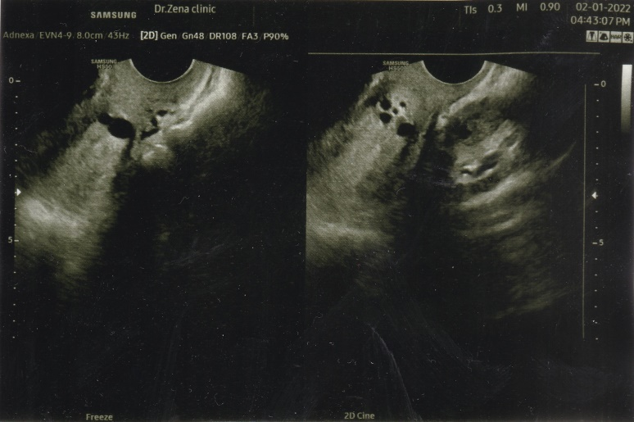

Figs 1 show multiple nabothian cysts by transvaginal approach.

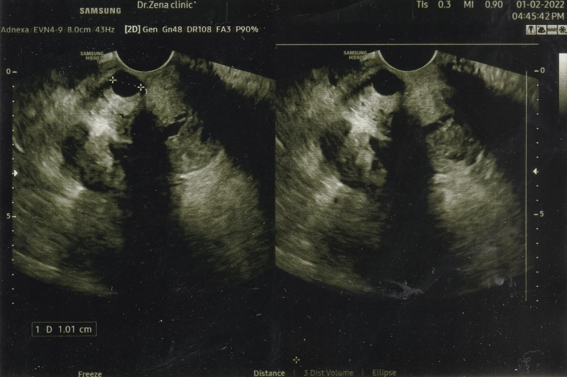

Fig 2 show single nabothian cyst by transvaginal approach.

**Conclusion:**

Early detection and treatment of nabothian cysts can aid in decreasing female infertility. This study focus on infertility caused by nabothian cysts and their detection by transabdominal and transvaginal ultrasound approaches.

**References:**

1. **Johnson NP. Review of Lipiodol treatment for infertility - an innovative treatment for endometriosis-related infertility? Australian and New Zealand Journal of Obstetrics and Gynaecology. 2013;54(1):9–12.**
2. **Sosnovski V, Barenboim R, Cohen HI, Bornstein J. Complex nabothian cysts: A diagnostic dilemma. Archives of Gynecology and Obstetrics. 2008;279(5):759–61.**
3. **Yıldız Ç, Özsoy A, Bahçe S, Sümer D, Çetin A. Multiple and large nabothian cysts: a case report. Cumhuriyet Medical Journal. 2009 Dec 14;31(4):456-9.**
4. **Yelikar K, Deshpande S, Deshmukh S, Pagare S. An unusual presentation of Nabothian cyst: A case report. International Journal of Reproduction, Contraception, Obstetrics and Gynecology. 2015;:1589–92.**
5. **Kuligowska E, Deeds L, Lu K. Pelvic pain: Overlooked and underdiagnosed gynecologic conditions. RadioGraphics. 2005;25(1):3–20.**
6. **Casey PM, Long ME, Marnach ML. Abnormal cervical appearance: What to do, when to worry? Mayo Clinic Proceedings. 2011;86(2):147–51.**
7. **Imaoka I, Wada A, Matsuo M, Yoshida M, Kitagaki H, Sugimura K. MR imaging of disorders associated with female infertility: Use in diagnosis, treatment, and management. RadioGraphics. 2003;23(6):1401–21.**
8. **DiMarco CS. Speroff L, Glass Rh, Kase Ng, editors. clinical gynecologic endocrinology and infertility. 6th Ed. Baltimore: Lippincott, Williams &amp; Wilkins, 1999:1–1200. Fertility and Sterility. 2000;74(2):425–6.**
9. **Wildenberg JC, Yam BL, Langer JE, Jones LP. US of the NONGRAVID cervix with multimodality imaging correlation: Normal appearance, pathologic conditions, and diagnostic pitfalls. RadioGraphics. 2016;36(2):596–617.**
10. **Turan G, Yalcin Bahat P, Aslan Çetin B. Spontaneus pregnancy after obstructive nabothian cyst treatment. International Journal of Reproduction, Contraception, Obstetrics and Gynecology. 2017;6(6):2625.**
11. **Yelikar K, Deshpande S, Deshmukh S, Pagare S. An unusual presentation of Nabothian cyst: A case report. International Journal of Reproduction, Contraception, Obstetrics and Gynecology. 2015;:1589–92.**
12. **Wu P-Y, Hsu K-F, Chang C-H, Chang F-M. Ultrasonographic diagnosis and treatment of a giant uterine cervical Nabothian cyst. Journal of Medical Ultrasound. 2012;20(3):169–72.**
13. **Majeed A, Bacha R, Farooq SM, Iqbal A, Mansoor AR, Liaqat M, Majeed S, Majeed R. Sonographic Association of Nabothian Cyst on Transvaginal Scan In Female with Primary and Secondary Infertility. Asian Journal of Allied Health Sciences (AJAHS). 2021 Aug 22:38-43.**
14. **Torky HA. Huge nabothian cyst causing hematometra (case report). European Journal of Obstetrics &amp; Gynecology and Reproductive Biology. 2016;207:238–40.**
15. **Vural F. Large nabothian cyst obstructing labour passage. JOURNAL OF CLINICAL AND DIAGNOSTIC RESEARCH. 2015;**
16. **Nigam A, Choudhary D, Raghunandan C. Large nabothian cyst: A rare cause of nulliparous prolapse. Case Reports in Obstetrics and Gynecology. 2012;2012:1–2.**
17. **Maharjan S, Tiwari M. An unusual presentation of a huge Nabothian cyst of cervix with manifestation of uterine prolapse: A case report. Clinical Medicine Insights: Case Reports. 2020; 13:117954762097467.**
18. **El-Agwany AS. Large multilocular cystic lesions in the uterine cervix: Differential diagnosis and significance. Journal of Medical Ultrasound. 2018;26(3):153.**
19. **Bin Park S, Lee JH, Lee YH, Song MJ, Choi HJ. Multilocular cystic lesions in the uterine cervix: Broad spectrum of imaging features and pathologic correlation. American Journal of Roentgenology. 2010;195(2):517–23.**
20. **Park SB, Moon MH, Hong SR, Lee MS, Cho HC, Han BH, et al. Adenoma Malignum of the uterine cervix: Ultrasonographic findings in 11 patients. Ultrasound in Obstetrics &amp; Gynecology. 2011;38(6):716–21.**
21. **Wildenberg JC, Yam BL, Langer JE, Jones LP. US of the NONGRAVID cervix with multimodality imaging correlation: Normal appearance, pathologic conditions, and diagnostic pitfalls. RadioGraphics. 2016;36(2):596–617.**
22. **Yitta S, Hecht EM, Mausner EV, Bennett GL. Normal or abnormal? demystifying uterine and Cervical Contrast Enhancement at Multidetector CT. RadioGraphics. 2011;31(3):647–61.**
23. **Sosnovski V, Barenboim R, Cohen HI, Bornstein J. Complex nabothian cysts: A diagnostic dilemma. Archives of Gynecology and Obstetrics. 2008;279(5):759–61.**
24. **Bin Park S, Lee JH, Lee YH, Song MJ, Choi HJ. Multilocular cystic lesions in the uterine cervix: Broad spectrum of imaging features and pathologic correlation. American Journal of Roentgenology. 2010;195(2):517–23.**
25. **Kerwin CM, Markese M, Moroney MR, Smith LP, Patel NU. Adenocarcinoma of the uterine cervix, gastric-type (GAS): a review of the literature focused on pathology and multimodality imaging. Abdominal Radiology. 2022 Nov 5:1-1.**
26. **Turan G, Yalcin Bahat P, Aslan Çetin B. Spontaneus pregnancy after obstructive nabothian cyst treatment. International Journal of Reproduction, Contraception, Obstetrics and Gynecology. 2017;6(6):2625.**
27. **Jemal A, Siegel R, Ward E, Murray T, Xu J, Thun MJ. Cancer statistics, 2007. CA: A Cancer Journal for Clinicians. 2007;57(1):43–66.**